Introduction
This program is designed to demonstrate methods. The program is for a bank, which will have five users with hard coded customer details, including the name, balance, pin and whether or not they have an overdraft. The program will display two menus. The first menu will display two options for the user, Login or Exit. Should the user exit, the program will shut down, if they chose to login, they will be prompted to enter their pin code. If the pin code is correct, a new menu will be displayed with four options, including; Lodge, Withdraw, Change Pin and Quit.

The Login method will take the pin from the user, and if it’s valid, it will continue on to the main menu, if it is not valid, it will go back to the login menu.

The main menu itself will be done in a method, with the subscript of the pin (which was used to login in) will be passed down to this method.

Both the lodgement and withdrawal method will pass the amount entered to their selected methods, which will then update the customers balance and return it. If the user has an overdraft, they are eligible to take out more money than they have in their account.

Changing the pin will pass the new pin entered to a method. This method will then check whether or not the pin is in use. If it is, the user will be asked to enter a valid option for a pin, when they do, it will be passed back to the method and the array holding the pins will be updated.

The program only ends when the users chooses quit from the login menu.

Steps

- Import Date
- Import Scanner
- Start Class
- Declare variables globally
- Start Main Method
- Print date
- Call the Login Menu method

Login Menu Method
- Start Method
- Declare variables
- Display the login menu
- Prompt the user for input (using the numbers 1-2 only)
- Validate the input using the method “validationcho”
- Pass strchoice to the validation method
- If the user enters 1
  - Prompt them to enter their pin
  - Validate the input using the method “validationpin”
  - Pass strpin to this method
  - Use a for loop to check if the pin exists in the array
    - If the pin entered matches one in the array, print Pin Found
    - Set found flag to true
    - Let sub = to i
    - Exit loop
  - If found is still false, tell the user the pin was not found
    - Re-display the menu by calling the loginmenu method
    - Else, call the ATMMenu method and pass down sub
- If the user enters 2
  - End the program by calling the quit method

Quit Method
- Start Method
- Print an ending sentence (Thank you for using our ATM, Goodbye)
- Exit program

ATM Menu Method
- Start Method
- Declare variables
- Welcome the user, showing their name and balance
- If overdraft is 1
  - Tell the user they have an overdraft
  - Else, tell them they don’t have one
- While the user has not entered option 4
  - Print out the menu
  - Prompt the user to enter an option
  - Validate the input using the menuvalidation method
  - Pass strmenuselect to this method
  - If the user enters 1
    - Prompt them to enter the amount they wish to lodge
    - Validate the input using the lodgevalidation method
    - Pass strlodgement to this method
    - Call the lodge method in order to do the calculation
    - Print out their new balance
  - Else if the user enters 2
    - Prompt them to enter the amount they wish to withdraw
    - Validate the input using the withdrawvalidation method
    - Pass strwithdrawal to this method
    - Call the withdraw method in order to do the calculation and check if they have an overdraft or not
  - Else if the user enters 3
    - Prompt them to enter their new pin
    - Validate the input using the changepinval method
    - Pass strpin2 to this method
    - Call the method newpin and have the new pin returned to the method
- When the user enters option 4, tell them they have logged out and call the loginmenu method

Lodgement Method
- Add the balance in the array with the amount entered to lodge
- Show the user their updated details, including their new balance
- If overdraft[sub] is equalled to 1
  - Tell them they have an overdraft
  - Otherwise, tell them they don’t have one
- Return the new balance (lodgement)

Withdrawal Method
- If overdraft is 0
  - And if the balance is less than the amount they wish to withdraw
    - Tell the user they have insufficient funds
  - Otherwise, take the amount withdrawn from the balance
  - Reprint the user details with the updated balance
  - Return the withdrawal
- Else if the overdraft is 1
  - Take the amount withdrawn from the balance
  - Reprint the user details with the updated balance
  - Return the withdrawal
- Return the balance (withdrawal)

Change PIN Method
- Declare variable
- Set found to false
- While found is false
  - Use a for loop to search the pins array
    - If the pin entered matches any pin in the array
      - Tell the user that the pin is in use
      - Leave found as false
      - Reprompt the user to enter their new pin
      - Validate the pin entered with the changepinval method
      - Pass strpin2 to this method
      - Set i to equal 0
      - Set sub to equal i
      - Use break to exit the if statement
    - Else
      - Set found to true
- If found is true
  - Tell the user that their pin has changed
- Return the new pin

Validation Methods on Page 5

Login Menu Validation
- While the input doesn’t match 1-2
  - Beep
  - Tell the user that they have to enter valid options (1-2)
  - Reprompt the user
- Return the input as an integer

Pin Validation
- While the input doesn’t match 3 digits
  - Beep
  - Tell the user that there is an error, only enter 3 digits
  - Reprompt the user
- Return the input as an integer

Main Menu Validation
- While the input doesn’t match 1-4
  - Beep
  - Tell the user to enter valid options only
  - Display the menu
  - Reprompt the user
- Return the input as an integer

Change PIN Validation
- While the input doesn’t match 3 digits
  - Beep
  - Tell the user that it’s 3 digits only
  - Reprompt the user to enter their new pin
- Return the input as an integer

Lodgement Validation
- While the input doesn’t match digits
  - Beep
  - Tell the user that it’s digits only
  - Reprompt the user to enter lodgement
- Return the input as an integer

Withdrawal Validation
- While the input doesn’t match digits
  - Beep
  - Tell the user that it’s digits only
  - Reprompt the user to enter withdrawal
- Return the input as an integer

Program Walkthrough

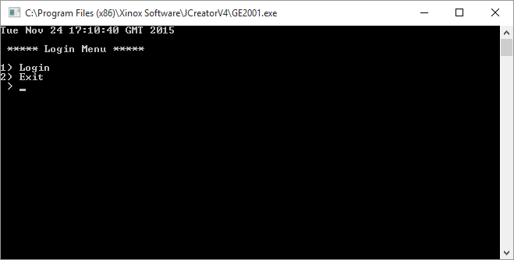
The program starts by displaying the date, time and login menu

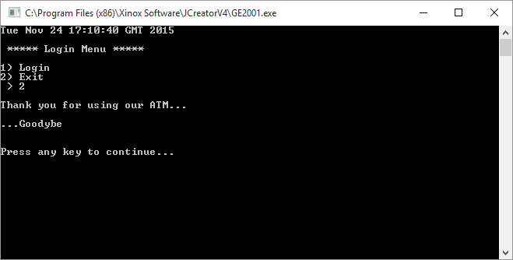
When the user enters 2, the program shuts down

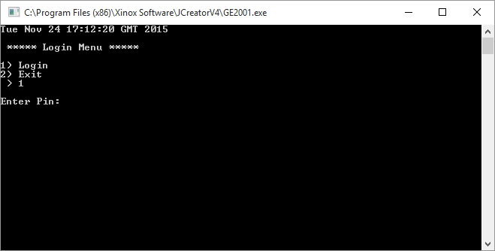
When the user enters 1, they are then asked to enter their pin

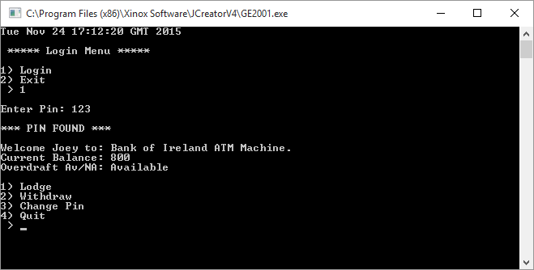
When the user enters their pin, they are welcomed to the program, and their current balance and overdraft are displayed, along with the main menu of the ATM

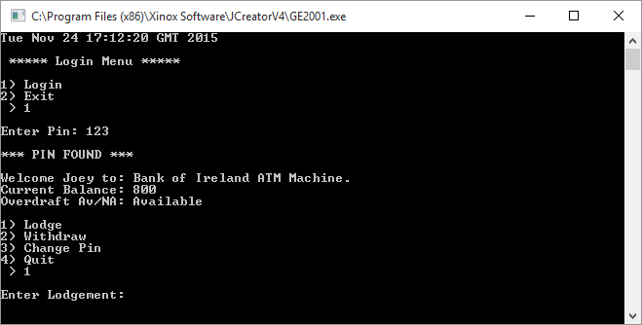
When the user enters option 1, they are asked to enter the amount they wish to lodge

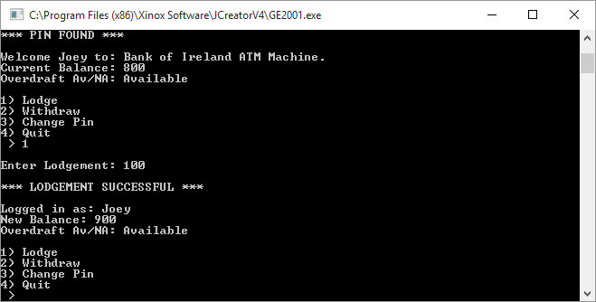
When they enter the amount, their information and the ATM Menu are displayed again with the users updated balance

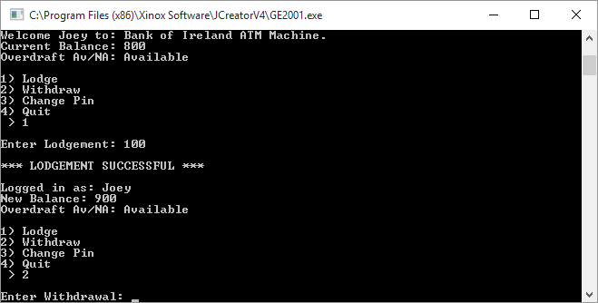
When the user enters option 2, they are asked to enter the amount they wish to withdraw

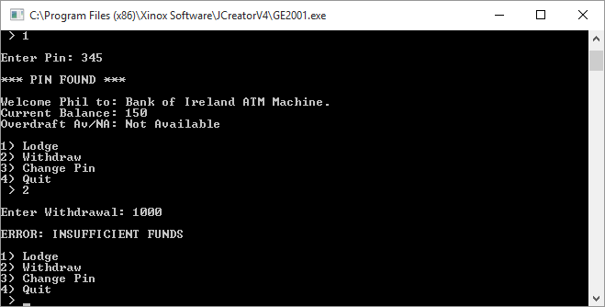
If the user does not have an overdraft and they attempt to take out more money than they have, they are told they have insufficient funds and are shown the menu again

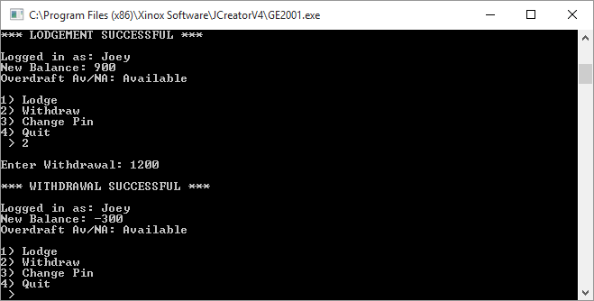
When the user enters a valid withdrawal amount, their information and the ATM Menu are displayed again and the users balance is updated

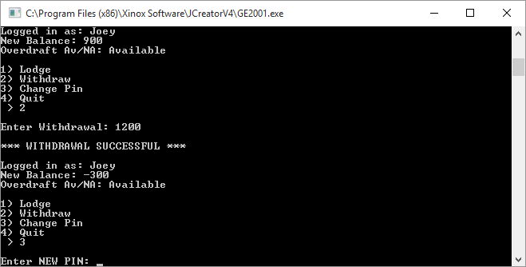
When the user enters option 3, they are asked to enter their new pin

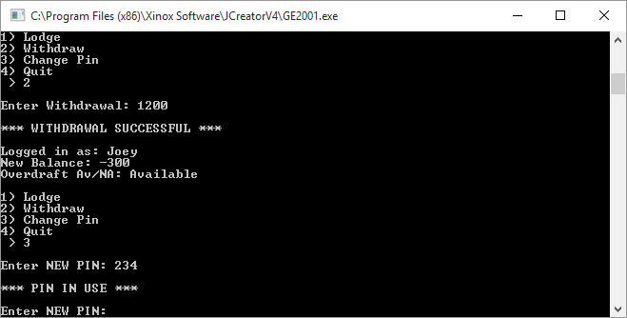
If the user enters a pin that is already in use, they are told this and asked to enter another pin

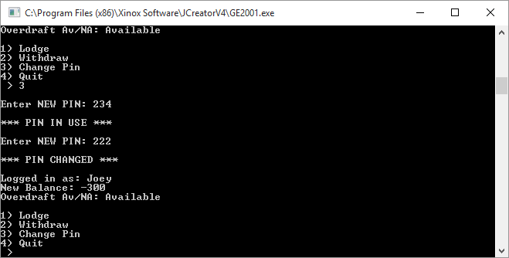
When the user changes their pin, they are told that their pin has been changed, their information and the ATM Menu are displayed again

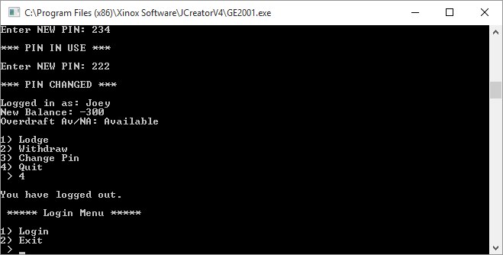
When the user enters option 4, they are logged out

In order to exit the program, the user must enter option 2 at the Login Menu

Test Bed

Scenario | Data Entered | Expected Result | Actual Result
Login Menu  - Login  - Exit | 4 | ERROR: Please Enter Valid Options Only  Login Menu  - Login  - Exit | ERROR: Please Enter Valid Options Only  Login Menu  - Login  - Exit
Login Menu  - Login  - Exit | 2 | Thank you for using our ATM, Goodbye | Thank you for using our ATM, Goodbye
Login Menu  - Login  - Exit | 1 | Enter Pin | Enter Pin
Enter Pin | 222 | Pin was not found | Pin was not found
Enter Pin | asd | ERROR: 3 Digits ONLY | ERROR: 3 Digits ONLY
Enter Pin | 123 | Pin Found  Welcome name,  Balance, Overdraft  1) Lodge  2) Withdraw  3) Change Pin  4) Quit | Pin Found  Welcome name,  Balance, Overdraft  1) Lodge  2) Withdraw  3) Change Pin  4) Quit
Pin Found  Welcome name,  Balance, Overdraft  1) Lodge  2) Withdraw  3) Change Pin  4) Quit | 5 | ERROR: Please Enter Valid Options Only | ERROR: Please Enter Valid Options Only
Pin Found  Welcome name,  Balance, Overdraft  1) Lodge  2) Withdraw  3) Change Pin  4) Quit | 1 | Enter Lodgement: | Enter Lodgement:
Enter Lodgement: | thousand | ERROR: Digits Only  Enter Lodgement: | ERROR: Digits Only  Enter Lodgement:
ERROR: Digits Only  Enter Lodgement: | 1000 | Lodgement Successful  Logged in as: name,  New Balance, Overdraft Av/NA  1) Lodge  2) Withdraw  3) Change Pin  4) Quit | Lodgement Successful  Logged in as: name,  New Balance, Overdraft Av/NA  1) Lodge  2) Withdraw  3) Change Pin  4) Quit
Lodgement Successful  Logged in as: name,  New Balance, Overdraft Av/NA  1) Lodge  2) Withdraw  3) Change Pin  4) Quit | 2 | Enter Withdrawal: | Enter Withdrawal:
Enter Withdrawal: | Two | ERROR: Digits Only  Enter Withdrawal: | ERROR: Digits Only  Enter Withdrawal:
ERROR: Digits Only  Enter Withdrawal: | 1000 | Withdrawal Successful  Logged in as: name,  New Balance, Overdraft Av/NA  1) Lodge  2) Withdraw  3) Change Pin  4) Quit | Withdrawal Successful  Logged in as: name,  New Balance, Overdraft Av/NA  1) Lodge  2) Withdraw  3) Change Pin  4) Quit
Withdrawal Successful  Logged in as: name,  New Balance, Overdraft Av/NA  1) Lodge  2) Withdraw  3) Change Pin  4) Quit | 3 | Enter New Pin: | Enter New Pin:
Enter New Pin: | 234 | Pin in Use  Enter New Pin: | Pin in Use  Enter New Pin:
Pin in Use  Enter New Pin: | www | ERROR: 3 digits Only  Enter New Pin: | ERROR: 3 digits Only  Enter New Pin:
ERROR: 3 digits Only  Enter New Pin: | 222 | Pin Changed  Logged in as: name,  New Balance, Overdraft Av/NA  1) Lodge  2) Withdraw  3) Change Pin  4) Quit | Pin Changed  Logged in as: name,  New Balance, Overdraft Av/NA  1) Lodge  2) Withdraw  3) Change Pin  4) Quit
Pin Changed  Logged in as: name,  New Balance, Overdraft Av/NA  1) Lodge  2) Withdraw  3) Change Pin  4) Quit | 4 | You have logged out  Login Menu  1) Login  2) Exit | You have logged out  Login Menu  1) Login  2) Exit
You have logged out  Login Menu  1) Login  2) Exit | 2 | Thank you for using our ATM, Goodbye | Thank you for using our ATM, Goodbye

Conclusion/Evaluation
Overall, the program works as expected, however early on into the work, there was a problem when changing the users pin, it would overwrite the second person in the array with the first person’s details. This was fixed using a while a loop.

In order to make the program better, I would put a limit on how much the user could lodge into their bank account. I would also put all the validation methods into one method instead of using multiple ones.

The test bed results match the outcomes expected of this program.

